**Evaluating programs and ministries through the lens of Mission & Discipleship.**

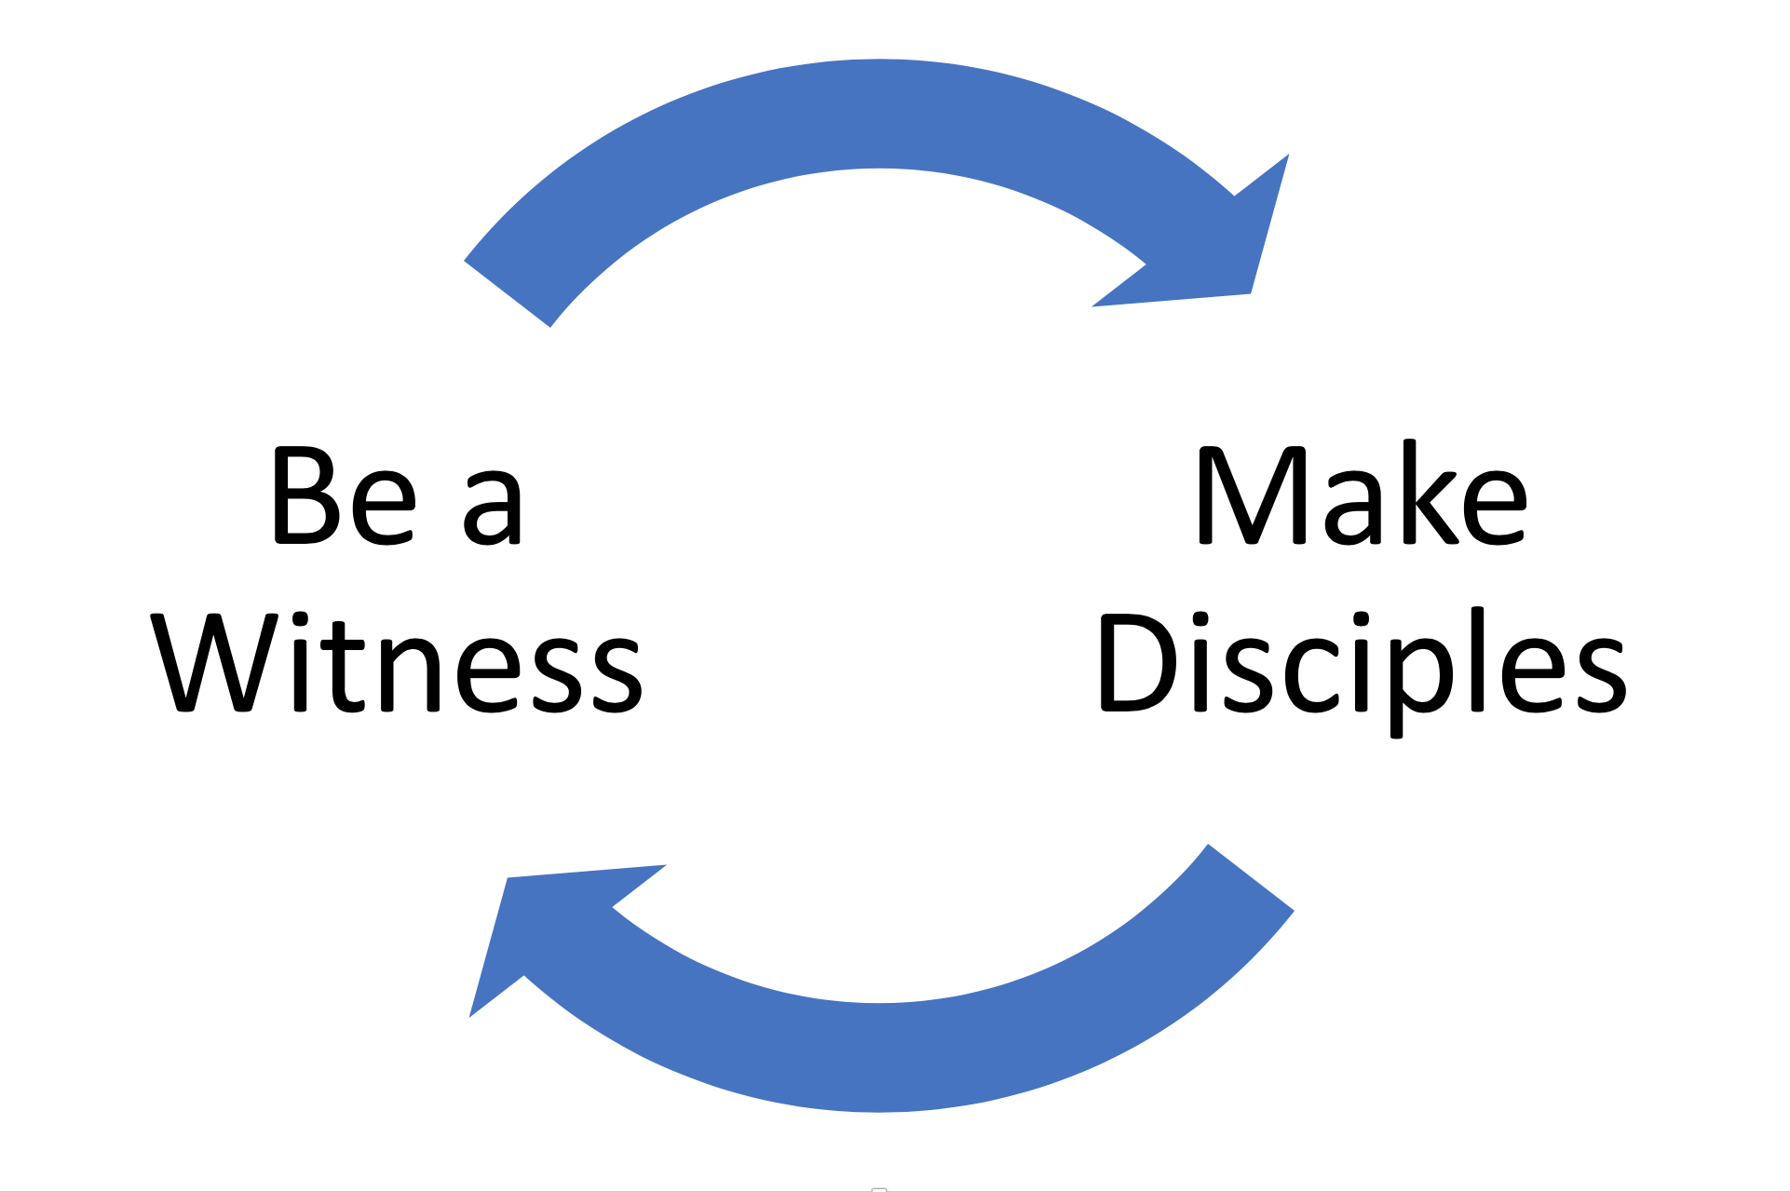

As I read through the New Testament, it seems to me that Jesus made it very clear that at the very least that those who call themselves followers of Jesus (Disciples), and those who gather in the name of Jesus (the church) are called by Jesus, at the very least, to do one thing and be one thing. Sure, there are many other things followers of Jesus should do (loving our neighbours and loving each other, be a voice for justice, cloth the naked and feed the sick to name a few), but all these other things flow from and are impacted by the one thing Jesus, specifically called us to do and the one thing Jesus specifically said we are to be.

The one thing Jesus specifically called us to do is Make Disciples. Jesus said: “All authority in heaven and on earth has been given to me. Therefore go and make disciples of all nations, baptizing them in the name of the Father and of the Son and of the Holy Spirit. (Matthew 28: 18 & 19).

There are many ways to make disciples, there are lots of different programs, different ministries and different approaches. The real question we need to ask of ourselves and our ministries is are we actually making disciples, are our ministries, programs or approaches actually (literally) making disciples? Can we list the names and point out the people who have become disciples (followers of Jesus) as a direct result of our efforts? I think an important question we need to ask ourselves and of all our programs and ministries we run is “Does it make disciples?”

The one thing that Jesus specially called us to be, is a witness: “ But you will receive power when the Holy Spirit comes on you, and you will be my witnesses in Jerusalem, and in all Judea and Samaria, and to the ends of the earth.” (Acts 1:8).

When Jesus calls us to be his witnesses, he means that we would give witness (testify to; give or afford evidence of) to the resurrected Jesus and the impact that he has on our lives and the purpose and direction which he gives us for life (and everything else). Our actions, our words, the ministries we engage in, the programs we run and the way we interact with those around us (inside and outside the church) is meant to give witness to Jesus, all that he is and that that he has done. Because we are called by Jesu to be His witnesses, I think one of the most important questions we need to ask ourselves and of all the programs and ministries we run is: “Does it reveal Jesus?”

These two questions, “Does it make Disciples?” & “Does it reveal Jesus?”, form a helpful lens through which we can view and evaluate a churches ministry and programs and help us be honest about the extent to which a church's ministries and programs are in line with Jesus’ call to make disciples and be a witness.

I am reminded of a playgroup ministry that was part of a church I was leading. It had been running for more than 17 years and it was a strong and healthy ministry, it had a good team, a great program, over 30 families regularly engaged, and it was well regarded and respected by the wider community. The only issue was that after 17 years no one could point to a single person coming to know Jesus in a real and personal way nor anyone joining the church or attending the church - ever!

While a good ministry, it wasn’t making disciples and it wasn’t revealing or raising an interest in Jesus. There were many reasons, but the two that stood out were 1) everyone in the team were so busy running the program there was no time to build relationships with the very people they were trying to reach; and 2) there was no training or equipping in evangelism or faith sharing for team members so that they had the skills and confidence in sharing their faith or giving witness to Jesus. With essential no fruit (no witness to Jesus and no disciples), we made the decision to close the ministry and begin training and equipping people so that they could share their faith and have the room to connect relationally with those connected with the ministry from outside the church. Over the next few years, we saw people come to know Jesus, be baptised and join the church.

**Instructions for Leadership and/or Pastor teams.**

Below is a simple 4x4 grid that asks our two questions: 1) Does it make disciples? & 2) Does it reveal Jesus? As a team, compile a list of your church's ministries and programs and then place them on the grid, not where they are meant to be, but according to the extent to which they actually make disciples and/or reveal Jesus. The purpose of some ministries or programs is not intended to make disciples or reveal Jesus and that’s ok. A church needs these, but without ministries that do make disciples and reveal Jesus, a church won’t grow or be fruitful and is in danger of decline and disconnect from its local community.

Be honest and assess each of your church's ministries and programs through the lens of mission and discipleship. Use the Reflections & Questions section below to help assess and reflect on the ministry and/or program on its effectiveness, future and improvements. Use your reflections and answers to develop a strategy to implement and/or improve the mission and discipleship capacity of your church.

**Mission & Discipleship Lens**

|  |  |  |  |  |  |  |  |  |
| --- | --- | --- | --- | --- | --- | --- | --- | --- |
| Does it reveal Jesus? | | Yes | 1 | | 2 | 3 | | 4 |
|  | 5 | | 6 | 7 | | 8 |
| No | 9 | | 10 | 11 | | 12 |
|  | 13 | | 14 | 15 | | 16 |
|  | No | |  | Does it make disciples? | | Yes |
|  |  | | | | | |
| Ministries/Programs located here | Ministries/Programs located here | | | Ministries/Programs located here | | | Ministries/Programs located here | |
| 9, 13, 14 | 1, 2, 5, 12, 15, 16 | | | 6, 7, 10, 11 | | | 3, 4, 8 | |
|  |  | | |  | | |  | |

**Reflections & Questions**

Ask the following questions of each ministry and programs depending on where you assessed it to be on the Mission & Discipleship Lens.

|  |  |  |  |
| --- | --- | --- | --- |
| 9, 13, 14 | 1, 2, 5, 12, 15, 16 | 6, 7, 10, 11 | 3, 4, 8 |
| * What is the purpose? * Does it support the vision & how? * Should it close? * Would you do this if starting the church today? | * Does it meet its purpose? * Is there a parallel ministry? * Is it bearing fruit? * How can this be enhanced, reshaped, restructured, resourced to increase the missional and/or discipleship focus? | * Is this core to the vision? * How can this be enhanced, reshaped, restructured, resourced to increase the missional and/or discipleship focus? * Where is it in its life-span? * Has the need for the ministry past? | * In this ministry at the core of the vision? * How can these ministries be increased & improved? * Do they need more funding, staffing, resourcing? |
| Ministries/Programs  to focus on | Ministries/Programs  to focus on | Ministries/Programs  to focus on | Ministries/Programs  to focus on |
|  |  |  |  |